**Design and Implementation of Employee Information and Payroll Management System**

by

**Md. Mafujul Hasan**

ID: CSE1903018137

**Nazmul Hossain**

ID: CSE1903018114

Supervised by

**Bulbul Ahamed**

Submitted in partial fulfillment of the requirements for the degree of Bachelor of Science in Computer Science and Engineering



**DEPARTMENT OF COMPUTER SCIENCE AND ENGINEERING**

**SONARGAON UNIVERSITY (SU)**

September 2023

**Design and Implementation of Employee Information and Payroll Management System**

by

**Md. Mafujul Hasan**

ID: CSE1903018137

**Nazmul Hossain**

ID: CSE1903018114

Supervised by

**Bulbul Ahamed**

Submitted in partial fulfillment of the requirements for the degree of Bachelor of Science in Computer Science and Engineering



**DEPARTMENT OF COMPUTER SCIENCE AND ENGINEERING**

**SONARGAON UNIVERSITY (SU)**

September 2023

**APPROVAL**

The project titled “**Design and Implementation of Employee Information and Payroll Management System**” submitted by Md. Mafujul Hasan (CSE1903018137), Nazmul Hossain (CSE1903018114) to the Department of Computer Science and Engineering, Sonargaon University (SU), has been accepted as satisfactory for the partial fulfillment of the requirements for the degree of Bachelor of Science in Computer Science and Engineering and approved as to its style and contents.

**Board of Examiners**

|  |  |
| --- | --- |
| ----------------------------------------  **Bulbul Ahamed**  Associate Professor and Head,  Department of Computer Science and Engineering  Sonargaon University (SU) | **Supervisor** |
| ----------------------------------------  (Examiner Name and Signature)  Department of Computer Science and Engineering  Sonargaon University (SU) | **Examiner 1** |
| ----------------------------------------  (Examiner Name and Signature)  Department of Computer Science and Engineering  Sonargaon University (SU) | **Examiner 2** |
| ----------------------------------------  (Examiner Name and Signature)  Department of Computer Science and Engineering  Sonargaon University (SU) | **Examiner 3** |

**DECLARATION**

We, hereby, declare that the work presented in this report is the outcome of the investigation performed by us under the supervision of **Bulbul Ahamed, Associate Professor** and **Head,** Department of Computer Science and Engineering, Sonargaon University, Dhaka, Bangladesh. We reaffirm that no part of this project has been or is being submitted elsewhere for the award of any degree or diploma.

|  |  |
| --- | --- |
| Countersigned  ------------------------------  **(Bulbul Ahamed)**  **Supervisor** | Signature  ------------------------  Md. Mafujul Hasan  ID: CSE1903018137  ------------------------  Nazmul Hossain  ID: CSE1903018114 |

**ABSTRACT**

This project focuses on designing and implementing an integrated system for managing employee information, payroll processing, and communication using a chat application. The system includes features such as employee data management, payroll calculations, tax deductions, and benefits administration. The chat application enables real-time communication and collaboration among employees, facilitating efficient workflow and knowledge sharing. The system aims to enhance organizational efficiency, accuracy, and employee satisfaction by automating processes and fostering effective communication.

# ACKNOWLEDGMENT

At the very beginning, we would like to express my deepest gratitude to the Almighty Allah for giving us the ability and the strength to finish the task successfully within the schedule time.

We are auspicious that we had the kind association as well as supervision of **Bulbul Ahamed**, Associate Professor and Head, Department of Computer Science and Engineering, Sonargaon University whose hearted and valuable support with best concern and direction acted as necessary recourse to carry out our project.

We would like to convey our special gratitude to **Brig. Gen. (Retd) Prof. Habibur Rahman Kamal, ndc, psc** Dean, Faculty of Science and Engineering for his kind concern and precious suggestions.

We are also thankful to all our teachers during our whole education, for exposing us to the beauty of learning.

Finally, our deepest gratitude and love to my parents for their support, encouragement, and endless love.

**LIST OF ABBREVIATIONS**

CSS Cascading Style Sheets

DBMS Database Management System

DFD Data Flow Diagram

ERD Entity Relationship Diagram

ERP Enterprise Resource Planning

HR Human Resources

HTML Hyper Text Markup Language

JS Java Script

MySQL My Structured Query Language

OOP Object-Oriented Programming

PHP Hypertext Preprocessor

SDM Systems Development Method

SFD System Flow Diagram

UML Unified Modeling Language

**TABLE OF CONTENTS**

|  |  |  |  |  |  |
| --- | --- | --- | --- | --- | --- |
| Title | | |  | | Page No. |
|  | | | | | |
| DECLARATION …………………………………………………………..…….. | | | | | iii |
| ABSTRACT ……………………...………………………………………………. | | | | | iv |
| ACKNOWLEDGEMENT ………………………………………….…………… | | | | | v |
| LIST OF ABBREVIATIONS ………….………………………………………… | | | | | vi |
|  | | | | | |
| CHAPTER 1 | | |  | | 1 – 3 |
| INTRODUCTION TO PAYROLL MANAGEMENT SYSTEM | | | | |  |
|  | 1.1 | Background of the Study ……………………………………………. | | | 1 |
|  | 1.2 | Problem Statement ……………………...………………………….... | | | 1 |
|  | 1.3 | Objectives ………………………………………….. …..……..…….. | | | 1 |
|  | 1.4 | Scope …………………….………………........................................... | | | 2 |
|  | 1.5 | Significance of the Study ………………………………….…………. | | | 3 |
|  | 1.6 | Proposed System …………………………………………………….. | | | 3 |
|  | | | | | |
| CHAPTER 2 | | |  | | 4 – 5 |
| LITERATURE REVIEW | | | | |  |
|  | 2.1 | Payroll Management Systems ………………………………….......... | | | 4 |
|  | 2.2 | Chat Applications in Organizations …………………………………. | | | 4 |
|  | 2.3 | Related Work ……………………………………………………… | | | 5 |
|  | 2.4 | Gap Analysis ………………………………………………………… | | | 5 |
|  | | | | | |
| CHAPTER 3 | | |  | | 6 – 20 |
| SYSTEM ANALYSIS AND DESIGN | | | | |  |
|  | 3.1 | Requirements Gathering …………………………………………….. | | | 6 |
|  | 3.2 | System Architecture …………………………………………………. | | | 7 |
|  | 3.3 | Database Design …………………………………………………… | | | 7 |
|  |  | 3.3.1 | | Branch Data Dictionary…………………………………… | 8 |
|  |  | 3.3.2 | | Designation Data Dictionary……………………………… | 8 |
|  |  | 3.3.3 | | Chat Data Dictionary……………………………………… | 9 |
|  |  | 3.3.4 | | Shift Data Dictionary……………………………………… | 9 |
|  |  | 3.3.5 | | Employee Data Dictionary………………………………… | 10 |
|  |  | 3.3.6 | | Payroll Data Dictionary……………………………………. | 11 |
|  |  | 3.3.7 | | Employee Leaves Data Dictionary………………………… | 12 |
|  |  | 3.3.8 | | Payroll Details Data Dictionary…………………………… | 12 |
|  |  | 3.3.9 | | Employee Attendance Data Dictionary…………………… | 13 |
|  |  | 3.3.10 | | Holidays Data Dictionary…………………………………. | 13 |
|  | 3.4 | User Interface Design ……………………………………………… | | | 13 |
|  | 3.5 | Chat Application Integration ………………………………………… | | | 14 |
|  | 3.6 | Unified Modeling Language ………………………………………… | | | 14 |
|  |  | 3.6.1 | | Sequence Diagram ………………………………………… | 15 |
|  |  | 3.6.2 | | Use-Case Diagram ………………………………………… | 16 |
|  |  | 3.6.3 | | Activity Diagram ………………………………………….. | 17 |
|  |  | 3.6.4 | | Class Diagram …………………………………………….. | 18 |
|  |  | 3.6.5 | | Deployment Diagram ……………………………………... | 19 |
|  |  | 3.6.6 | | System Flow Diagram ……………………………………. | 20 |
|  | | | | | |
| CHAPTER 4 | | |  | | 21 – 25 |
| IMPLEMENTATION | | | | |  |
|  | 4.1 | Technologies Used ………………………………………………… | | | 21 |
|  | 4.2 | Payroll Calculation Module ………………………………………….. | | | 21 |
|  |  | 4.2.1 | | Employee Module in Use-Case Diagram ………………… | 22 |
|  |  | 4.2.2 | | Payroll Module in State Diagram ………………………… | 23 |
|  | 4.3 | Employee Data Management ……………………………………… | | | 23 |
|  |  | 4.3.1 | | Employee Module in State Diagram ……………………… | 24 |
|  |  | 4.3.2 | | Leave Module in State Diagram …………………………… | 24 |
|  | 4.4 | Chat Application Development ……………………………………… | | | 25 |
|  | | | | | |
| CHAPTER 5 | | |  | | 26 – 27 |
| TESTING AND QUALITY ASSURANCE | | | | |  |
|  | 5.1 | Test Plan …………………………………………………………… | | | 26 |
|  | 5.2 | Test Cases ……………………………………………………………. | | | 26 |
|  | 5.3 | Performance Testing ………………………………………………… | | | 27 |
|  | 5.4 | Quality Assurance Measures ………………………………………… | | | 27 |
|  | | | | | |
| CHAPTER 6 | | |  | | 28 – 34 |
| PROJECT OUTPUT | | | | |  |
|  | 6.1 | Login System ……………………………………………………….. | | | 28 |
|  | 6.2 | Admin Dashboard …………………………………………………... | | | 28 |
|  | 6.3 | Employee Dashboard ……………………………………………….. | | | 29 |
|  | 6.4 | Branch View ………………………………………………………... | | | 29 |
|  | 6.5 | Shift View …………………………………………………………... | | | 30 |
|  | 6.6 | Department View …………………………………………………… | | | 30 |
|  | 6.7 | Designation View …………………………………………………… | | | 31 |
|  | 6.8 | Employee List View ………………………………………………… | | | 31 |
|  | 6.9 | Holiday List View …………………………………………………… | | | 32 |
|  | 6.10 | Leave List View ……………………………………………………... | | | 32 |
|  | 6.11 | Performance Analysis of an Employee ……………………………… | | | 33 |
|  | 6.12 | Payslip Generate …………………………………………………….. | | | 33 |
|  | 6.13 | Biometric Report View ……………………………………………... | | | 34 |
|  | 6.14 | Employee Chat Window View ………………………………………. | | | 34 |
|  | | | | | |
| CHAPTER 7 | | |  | | 35 |
| CONCLUSION AND FUTURE WORKS | | | | |  |
|  | 7.1 | Conclusion …………………………………………………………... | | | 35 |
|  | 7.2 | Limitations …………………………………………………………... | | | 35 |
|  | 7.3 | Future Works ………………………………………………………... | | | 35 |
|  | | | | | |
| REFERENCES ……………………………………………………….………….. | | | | | 36 |
|  | | | | | |

**LIST OF TABLES**

|  |  |  |
| --- | --- | --- |
| **Table No.** | **Title** | **Page No.** |
| Table 3.3.1 | Branch Data Dictionary | 8 |
| Table 3.3.2 | Designation Data Dictionary | 8 |
| Table 3.3.3 | Chat Data Dictionary | 9 |
| Table 3.3.4 | Shift Data Dictionary | 9 |
| Table 3.3.5 | Employee Data Dictionary | 10 |
| Table 3.3.6 | Payroll Data Dictionary | 11 |
| Table 3.3.7 | Employee Leaves Data Dictionary | 12 |
| Table 3.3.8 | Payroll Details Data Dictionary | 12 |
| Table 3.3.9 | Employee Attendance Data Dictionary | 13 |
| Table 3.3.10 | Holidays Data Dictionary | 13 |

**LIST OF FIGURES**

|  |  |  |
| --- | --- | --- |
| **Figure No.** | **Title** | **Page No.** |
| Fig.3.6.1 | Sequence Diagram | 15 |
| Fig.3.6.2 | Use-Case Diagram | 16 |
| Fig.3.6.3 | Activity Diagram | 17 |
| Fig.3.6.4 | Class Diagram | 18 |
| Fig.3.6.5 | Deployment Diagram | 19 |
| Fig.3.6.6 | System Flow Diagram | 20 |
| Fig.4.2.1 | Employee Module in Use-Case Diagram | 22 |
| Fig.4.2.2 | Payroll Module in State Diagram | 23 |
| Fig.4.3.1 | Employee Module in State Diagram | 24 |
| Fig.4.3.2 | Leave Module in State Diagram | 24 |
| Fig.6.1 | Login System | 28 |
| Fig.6.2 | Admin Dashboard | 28 |
| Fig.6.3 | Employee Dashboard | 29 |
| Fig.6.4 | Branch View | 29 |
| Fig.6.5 | Shift View | 30 |
| Fig.6.6 | Department View | 30 |
| Fig.6.7 | Designation View | 31 |
| Fig.6.8 | Employee List View | 31 |
| Fig.6.9 | Holiday List View | 32 |
| Fig.6.10 | Leave List View | 32 |
| Fig.6.11 | Performance Analysis of an Employee | 33 |
| Fig.6.12 | Payslip Generate | 33 |
| Fig.6.13 | Biometric Report View | 34 |
| Fig.6.14 | Employee Chat Window View | 34 |

**CHAPTER 1**

**INTRODUCTION TO PAYROLL MANAGEMENT SYSTEM**

The design and implementation of an employee information and payroll management system play a crucial role in effectively managing human resources and ensuring accurate and timely payroll processing. This system not only simplifies the process of managing employee information but also streamlines payroll calculations, ensuring compliance with legal and regulatory requirements. Efficient employee information and payroll management systems contribute to organizational productivity, employee satisfaction, and financial stability [1].

**1.1 Background of the Study**

Traditionally, payroll management systems relied heavily on labor-intensive manual processes, leaving room for errors, delays, and inefficiencies. Such systems lacked seamless communication channels, making it challenging for employees to seek clarifications regarding their salaries and deductions. The advent of digital technologies and communication tools has opened up new possibilities for comprehensive payroll management systems that harness the power of automation and real-time interaction.

**1.2 Problem Statement**

The conventional payroll management systems fail to address the growing complexities of payroll calculations and communication gaps within organizations. Manual data entry is prone to errors, and the absence of instant communication channels can lead to delays in resolving salary-related queries. Organizations need a robust online solution that eliminates manual intervention, enhances accuracy, and provides a seamless platform for employee-employer interaction.

**1.3 Objectives**

1. Develop an efficient online payroll management system with a user-friendly interface.
2. Automate payroll calculations to minimize errors and save time.
3. Incorporate a secure and streamlined chat application for seamless communication.
4. Ensure data accuracy and confidentiality through robust security measures.
5. Provide customization options to accommodate diverse organizational needs.
6. Evaluate the system's effectiveness and efficiency through rigorous testing.
7. Propose recommendations for future enhancements and improvements.

**1.4 Scope**

The scope of the project book on an online payroll management system with a chat application encompasses various components and considerations that contribute to its successful implementation. The key aspects of the scope are as follows:

1. Payroll Management System:
2. Employee Data Management: The system will store and manage essential employee data such as personal information, salary details, tax-related information, and employment history.
3. Salary Calculations: The system will automate salary calculations, taking into account factors like attendance, leaves, overtime, bonuses, and deductions.
4. Taxation Management: It will handle tax calculations, generate tax forms, and ensure compliance with relevant tax regulations.
5. Benefits and Deductions: The system will account for employee benefits, deductions, and allowances based on the organization's policies.
6. Leave Management: It will incorporate leave tracking and management features, allowing employees to apply for leaves and receive approvals.
7. Payroll Processing: The system will generate accurate and timely payrolls, including payslips, tax reports, and other relevant documents.
8. Reporting and Analytics: It will provide comprehensive reporting and analytical capabilities to track payroll expenses, employee costs, and other key metrics.
9. Chat Application Integration:
10. Real-time Communication: The integrated chat application will enable smooth and efficient communication between employees and payroll administrators.
11. Query Resolution: Employees can seek assistance, ask questions, and resolve payroll-related queries through the chat application.
12. Notifications and Reminders: The chat application will send notifications and reminders regarding payroll-related deadlines, updates, and announcements.
13. Document Sharing: Employees can securely share payroll-related documents, such as tax forms, directly through the chat application.
14. Security and Privacy:
15. Data Security: The system will implement robust security measures to protect sensitive employee data from unauthorized access or breaches.
16. Role-based Access Control: It will ensure that only authorized personnel have access to specific payroll functions and data.
17. Confidentiality: The system will maintain the confidentiality of employee financial information and other sensitive payroll-related data.
18. Scalability and Customization:
19. The system will be designed to accommodate the needs of organizations of different sizes and structures.
20. Customization options will allow organizations to tailor the system according to their specific policies, workflows, and regulatory requirements.
21. User Interface and Experience:
22. The system will have a user-friendly interface, ensuring ease of use for both employees and payroll administrators.
23. Intuitive navigation, clear instructions, and well-designed forms will be incorporated to enhance the user experience.
24. Evaluation and Testing:
25. The project book will include an evaluation phase to assess the system's performance, accuracy, and usability.
26. Testing methodologies, such as unit testing, integration testing, and user acceptance testing, will be employed to ensure the system's reliability and effectiveness.
27. Recommendations and Future Enhancements:
28. The book will provide recommendations for further improvements, such as additional features, integration with other systems, and automation of manual processes.
29. Future enhancements may include machine learning algorithms for predictive analytics, AI-based chatbots for automated query resolution, and mobile application support.

**1.5 Significance of the Study**

The significance of this project lies in its potential to revolutionize the way organizations manage their payroll processes. By integrating a chat application within the payroll management system, it aims to enhance employee engagement, reduce manual errors, ensure timely communication, and establish a centralized platform for efficient payroll operations. The study holds relevance for businesses across industries, enabling them to optimize operational efficiency, improve employee satisfaction, and align with the evolving digital landscape.

**1.6 Proposed System:**

An Online System, where employees can apply for leaves and superior of employee can approve / reject leave requests. HR Manager can manage attendance of all employees and manage Payroll of all employees, managing shifts, allotting particular branch of the company to add new or existing employees. There is also a feature of online chatting for communicating the information amongst the stakeholders of the system.

**CHAPTER 2**

**LITERATURE REVIEW**

Employee information and payroll management systems play a vital role in modern organizations, enabling efficient and accurate handling of employee data, payroll processing, and related administrative tasks. The design and successful implementation of such systems are crucial for ensuring smooth and effective HR operations in today's rapidly evolving digital landscape. This literature review aims to explore existing research and industry publications to gain insights into the best practices, methodologies, challenges, and benefits associated with the design and implementation of employee information and payroll management systems [2].

**2.1 Payroll Management Systems**

Payroll management systems play a crucial role in the efficient and accurate processing of employee wages, benefits, tax deductions, and related financial aspects within organizations. The design and successful implementation of such systems are pivotal in ensuring compliance with legal regulations, minimizing errors, and streamlining payroll processes. This literature review aims to explore existing research and industry publications to gain insights into the design principles, implementation strategies, challenges, and benefits associated with Payroll Management Systems in the context of employee information and financial management [3].

**2.2 Chat Applications in Organizations**

Chat applications play a crucial role in organizations that have implemented an online payroll management system. Here are some key ways that chat applications enhance communication and collaboration within such systems:

1. Real-Time Communication: Chat applications provide a platform for employees, payroll administrators, and other stakeholders to communicate in real-time. This instant messaging capability allows for quick and efficient communication, enabling timely responses to payroll-related queries, clarifications, and updates.
2. Query Resolution: Employees often have questions or concerns related to their payroll, such as tax deductions, leave balances, or pay-related policies. Integrating a chat application within the payroll management system allows employees to seek clarification from payroll administrators directly. This helps in resolving queries promptly, reducing wait times, and enhancing overall employee satisfaction.
3. Collaboration and Problem-Solving: Chat applications enable collaborative problem-solving among team members involved in the payroll process. Payroll administrators, finance personnel, and HR representatives can discuss and evaluate payroll issues, discrepancies, or complex scenarios in real-time. This facilitates efficient decision-making and improves the accuracy of payroll calculations.
4. Document Sharing and Notifications: Chat applications integrated into payroll management systems often include file-sharing functionalities. This allows users to share important documents, such as payslips, tax withholding forms, or policy updates, securely within the chat interface. Additionally, notifications and alerts can be sent through the chat application to inform employees about important payroll deadlines or updates.
5. Remote Work and Geographically Dispersed Teams: With the rise of remote work and geographically dispersed teams, chat applications become even more important. They provide a centralized platform where employees located in different time zones or locations can connect and communicate seamlessly for payroll-related matters. This helps in maintaining a consistent and transparent payroll process regardless of physical location.
6. Employee Self-Service and Support: Chat applications integrated into the payroll management system can also offer self-service capabilities. Employees can access information about their payroll, such as payment history, tax forms, or benefit deductions, through the chat interface. This empowers employees to manage their payroll-related information independently, reducing the burden on HR and payroll departments.

**2.3 Related Work**

1. Several projects and studies have explored Online Payroll Management Systems.
2. These efforts provide valuable insights into system design, integration, and user adoption.

**2.4 Identified Gaps**

1. Security and Data Privacy: Ensuring the system has robust security measures to protect sensitive employee information and comply with data privacy regulations such as GDPR or HIPAA.
2. Integration with Existing Systems: Overcoming challenges in integrating the new system with existing HR or payroll systems to enable smooth data flow and avoid redundancy or data inconsistencies.
3. Scalability: Designing a system that can accommodate future growth and handle larger employee volumes without significant performance degradation.
4. User-Friendliness: Creating an intuitive and user-friendly interface for employees and HR staff to easily interact with the system, reducing the learning curve and improving overall productivity.
5. Reporting and Analytics: Incorporating comprehensive reporting and analytics capabilities to generate meaningful insights and facilitate data-driven decision-making. [4]

**CHAPTER 3**

**SYSTEM ANALYSIS AND DESIGN**

The online Payroll Management System with Chat Application Integration project aims to develop a comprehensive system that automates payroll processes while integrating a chat application for enhanced communication among employees and stakeholders. This project book report provides an overview of the system analysis and design phases, including requirements gathering, system architecture, data flow diagrams, database design, user interface design, and chat application integration.

**3.1 Requirements Gathering**

The design and implementation of an Employee Information and Payroll Management System requires a meticulous process of requirements gathering to ensure its effectiveness. This phase involves gathering and documenting the necessary functional and non-functional requirements to develop a comprehensive and tailored system that efficiently handles employee information and simplifies payroll management.

To initiate the requirements gathering phase, it is crucial to engage with key stakeholders, including HR professionals, payroll administrators, managers, and other relevant parties. Conducting interviews, surveys, and workshops serves as an opportunity to understand their unique needs, pain points, and expectations for the system.

In addition, a thorough analysis of existing employee information and payroll management processes is essential. This analysis involves studying the current workflows, procedures, and systems in place to identify areas for improvement and automation. Understanding the shortcomings and inefficiencies of the current processes is instrumental in proposing effective solutions that streamline employee information management and payroll processing.

During the requirements gathering phase, it is essential to identify both functional and non-functional requirements. Functional requirements define the specific features and functionalities the system must possess, such as employee data management, attendance tracking, leave management, benefits administration, payroll calculations, and reporting capabilities. Non-functional requirements encompass aspects such as system performance, data security, scalability, regulatory compliance, and usability.

Several techniques can be used to elicit requirements effectively, including brainstorming sessions, prototyping, surveys, and user observation. These techniques aid in gaining a comprehensive understanding of stakeholder needs and ensure accurate capturing of requirements [5].

**3.2 System Architecture**

The system architecture for an Employee Information and Payroll Management System encompasses the overall structure and organization of the software, hardware, and networking components that enable the system to function effectively. It defines how different modules and components interact and collaborate to manage employee information and process payroll efficiently.

At its core, the system architecture consists of three layers: the presentation layer, the application layer, and the data layer.

1. Presentation Layer: This layer focuses on the user interface and user experience aspects of the system. It provides a user-friendly interface that allows HR professionals, managers, and employees to access and interact with the system. This layer typically includes features such as login screens, dashboards, forms, and reports. It ensures that the system is intuitive, visually appealing, and accessible across different devices.
2. Application Layer: The application layer contains the business logic and functional components of the system. It handles the core functionalities, including employee data management, attendance tracking, leave management, benefits administration, payroll calculations, and reporting. This layer utilizes programming languages, frameworks, and libraries to implement the desired functionalities. Additionally, it may include integration with external systems, such as time clock or biometric devices to capture attendance data.
3. Data Layer: The data layer is responsible for storing and managing employee data, payroll data, and related information. It utilizes a database management system to store and retrieve data securely. The database schema is designed to ensure data accuracy, integrity, and compliance with legal and regulatory requirements. This layer may also involve data backup and recovery mechanisms to prevent data loss or corruption.

The system architecture may incorporate various technologies and tools, such as web-based frameworks, application servers, APIs (Application Programming Interfaces), and cloud platforms. The choice of technologies depends on factors such as scalability, security, performance, and budgetary considerations.

**3.3 Database Design**

Database Design involves designing the structure and organization of the system's database. It includes identifying the necessary database tables, defining the relationships between them, and determining the attributes to be stored. In the case of an online payroll management system, the database would need to store employee information, payroll data, chat history, user permissions, and other relevant data. The design should ensure data integrity, security, and efficient retrieval and manipulation.

**3.3.1 Branch Data Dictionary**

|  |  |  |  |  |
| --- | --- | --- | --- | --- |
| Field Name | Data type | Size | Constrain | Description |
| Branch_id | INT | 5 | PRIMARY KEY | ID of branch |
| Name | CHAR | 25 | NOT NULL | Name of branch |
| Branch_Address | VARCHAR | 100 | NOT NULL | Branch Address of company |
| Phone_number | INT | 10 | NOT NULL | Phone number of branch |
| Email | VARCHAR | 40 |  | Official email of branch |
| Establishment_date | DATE |  | NOT NULL | Establishment date of branch |
| Created_by | CHAR | 25 | NOT NULL | Name of the one who logged in and adds new branch |
| Created_date | DATE |  | NOT NULL | Created date of entry |
| Modified_date | DATE |  | NOT NULL | Modified date of entry |
| Status | INT | 1 | NOT NULL | (Either Active or Inactive) |

**3.3.2 Designation Data Dictionary**

|  |  |  |  |  |
| --- | --- | --- | --- | --- |
| Field Name | Data type | Size | Constrain | Description |
| Designation_id | INT | 5 | PRIMARY KEY | ID of designation |
| Designation_name | CHAR | 50 | NOT NULL | Name of designation |
| Department_name | CHAR | 30 | NOT NULL | Name of department |
| Created_date | DATE |  | NOT NULL | Created date of entry |
| Modified_date | DATE |  | NOT NULL | Modified date of entry |
| Status | TINYINT | 1 | NOT NULL | Either Active or Inactive |

**3.3.3 Chat Data Dictionary**

|  |  |  |  |  |
| --- | --- | --- | --- | --- |
| Field Name | Data type | Size | Constrain | Description |
| chat_id | INT | 5 | PRIMARY KEY | ID of chat. |
| from_id | INT | 5 | NOT NULL | ID of sender. |
| to_id | INT | 5 | NOT NULL | ID of receiver. |
| Message | VARCHAR | 500 | NOT NULL | Content to be sent and received. |
| Chattime | TIME |  | NOT NULL | Timings of conversation. |
| Status | TINYINT | 2 | NOT NULL | Either message read/unread. |

**3.3.4 Shift Data Dictionary**

|  |  |  |  |  |
| --- | --- | --- | --- | --- |
| Field Name | Data type | Size | Constrain | Description |
| Shift_id | INT | 5 | PRIMARY KEY | ID of particular shift |
| Shift_name | CHAR | 30 | NOT NULL | Name of shift |
| In_time | TIME |  | NOT NULL | Entrance time of employee |
| Out_time | TIME |  | NOT NULL | Leaving time of employee |
| Created_date | DATE |  | NOT NULL | Created date of entry |
| Modified_date | DATE |  | NOT NULL | Modified date of entry |
| Status | TINYINT | 1 | NOT NULL | Either active or Inactive |

**3.3.5 Employee Data Dictionary**

|  |  |  |  |  |
| --- | --- | --- | --- | --- |
| Field Name | Data type | Size | Constrain | Description |
| Employee_id | INT | 5 | PRIMARY KEY | ID of employee |
| Employee_Name | CHAR | 30 | NOT NULL | Name of employee |
| Current_address | VARCHAR | 80 | NOT NULL | Current address of employee |
| Permanent_address | VARCHAR | 80 | NOT NULL | Permanent address of employee |
| Mobile_number | BIGINT | 10 | NOT NULL | Mobile number of employee |
| Gender | ENUM |  | NOT NULL | MALE/FEMALE |
| Email | VARCHAR | 50 | NOT NULL | Email of employee |
| DOB | DATE |  | NOT NULL | Date of Birth |
| Qualification | VARCHAR | 20 |  | Qualification of employee |
| Joining_date | DATE |  | NOT NULL | Joining date of employee |
| Registration_date | DATE | 3 | NOT NULL | Registration date of company |
| Department_id | INT | 5 | FOREIGN KEY | ID of department |
| Branch_id | INT | 5 | FOREIGN KEY | ID of company |
| Designation_id | INT | 5 | FOREIGN KEY | ID of designation |
| Shift_id | INT | 5 | FOREIGN KEY | ID of shift |
| Password | VARCHAR | 50 | NOT NULL | Password to be entered while logging |
| Bank_account_number | BIGINT | 16 | UNIQUE KEY | Bank account number |
| Created_date | DATE |  | NOT NULL | Created date of entry |
| Modified_date | DATE |  | NOT NULL | Modified date of entry |
| Status | INT | 1 | NOT NULL | Either active or inactive |
| Confirm_password | VARCHAR | 20 | NOT NULL | Confirmation for password. |
| Roles | INT | 5 | NOT NULL | Role of employee whether he/she is admin,hr manager or normal employee. |
| city | CHAR | 15 | NOT NULL | city name of employee. |
| Basic_salary | FLOAT | 10,3 | NOT NULL | Basic salary of employee. |
| PT | FLOAT | 8,3 | NOT NULL | Predefined amount of Professional tax. |

**3.3.6 Payroll Data Dictionary**

|  |  |  |  |  |
| --- | --- | --- | --- | --- |
| Field Name | Data type | Size | Constrain | Description |
| Payroll_id | INT | 5 | PRIMARY KEY | ID of payroll |
| Payroll_month | INT | 2 | NOT NULL | Month of payroll |
| Payroll_year | INT | 4 | NOT NULL | Year of payroll |
| Employee_id | INT | 5 | FOREIGN KEY | ID of employee |
|  |  |
| Present_days | INT | 5 | NOT NULL | Present days of employee |
| Working_days | INT | 5 | NOT NULL | Working days of employee |
| Balance_leaves | INT | 5 | NOT NULL | Balance left for leaves |

**3.3.7 Employee Leaves Data Dictionary**

|  |  |  |  |  |
| --- | --- | --- | --- | --- |
| Field Name | Data type | Size | Constrain | Description |
| Employeeleaves_id | INT | 5 | PRIMARY KEY | ID of employee leaves |
| Leaveday_type | CHAR | 12 | NOT NULL | Full Day / First Half / Second Half |
| Leave_type | CHAR | 2 | NOT NULL | (Sick Leave(SL)/Casual Leave(CL)) |
| Leave_from_date | DATE |  | NOT NULL | Date from which leave is taken |
| Leave_to_date | DATE |  | NOT NULL | Till which date leave is to be taken |
| Employee_id | INT | 5 | FOREIGN KEY | ID of employee |
| Employee_name | CHAR | 30 | NOT NULL | Name of employee |
| Action_taken_by_id | INT | 5 | NOT NULL | ID of the person who takes action for leaves |
| Leave_reason_description | VARCHAR | 50 |  | Reason for leave |
| Leave_reject_reason_description | VARCHAR | 50 |  | Reason for rejecting the leave |
| Created_date | DATE |  | NOT NULL | Created date of entry |
| Modified_date | DATE |  | NOT NULL | Modified date of entry |
| Status | TINYINT | 1 | NOT NULL | Either Active or Inactive |

**3.3.8 Payroll Details Data Dictionary**

|  |  |  |  |  |
| --- | --- | --- | --- | --- |
| Field Name | Data type | Size | Constrain | Description |
| Payroll_detail_id | INT | 5 | PRIMARY KEY | ID of payroll details |
| Employee_id | INT | 5 | NOT NULL | ID of employee |
| Net_salary | FLOAT | 10,3 | NOT NULL | Net salary of employee |
| Bonus | FLOAT | 8,3 | NULL | Bonus of employee |

**3.3.9 Employee Attendance Data Dictionary**

|  |  |  |  |  |
| --- | --- | --- | --- | --- |
| Field Name | Data type | Size | Constrain | Description |
| Employee_attendance_id | INT | 5 | PRIMARY KEY | ID of employee attendance |
| Employee_id | INT | 5 | NOT NULL | ID of employee. |
|  |  |  |  |  |
| Checkin_time | TIME |  | NULL | Time at which employee checks in |
| Checkout_time | TIME |  | NULL | Time at which employee checks out |
| Bio_date | DATE | 2 | NOT NULL | Date from 1 to 30. |

**3.3.10 Holidays Data Dictionary**

|  |  |  |  |  |
| --- | --- | --- | --- | --- |
| Field Name | Data type | Size | Constrain | Description |
| Holiday_id | INT | 5 | PRIMARY KEY | ID for holiday |
| Holiday_name | CHAR | 30 | NOT NULL | Name of holiday |
| Holiday_description | VARCHAR | 50 | NOT NULL | Description of holiday |
| Holiday_date | DATE |  | NOT NULL | Date on which holiday is to be taken |
| Created_date | DATE |  | NOT NULL | Created date of entry |
| Modified_date | DATE |  | NOT NULL | Modified date of entry |
| Status | TINYINT | 1 | NOT NULL | Either Active or Inactive |

**3.4 User Interface Design**

User Interface Design focuses on designing the visual and interactive elements of the system. In an online payroll management system, the user interface should be intuitive, efficient, and user-friendly. It includes designing screens and forms for managing employee information, inputting payroll data, accessing chat functionality, generating reports, and performing other tasks. The design should provide a consistent look and feel, responsive layouts for different devices, and appropriate feedback to users.

**3.5 Chat Application Integration**

In designing and implementing an employee information and payroll management system with chat application integration, the goal is to create a comprehensive platform that enables efficient communication, data management, and payroll processing. The chat application component allows employees and managers to communicate and collaborate seamlessly within the system. It facilitates instant messaging, file sharing, and notifications, promoting real-time collaboration. Additionally, the system includes features for managing employee information, such as personal details, employment history, and performance data. The payroll management aspect automates salary calculations, tax deductions, and payment processing, ensuring accurate and timely compensation for employees. Integration with the chat application streamlines communication between HR administrators, managers, and employees regarding payroll-related queries, holidays, and leave requests. This unified system enhances productivity, simplifies information retrieval, and fosters a cohesive work environment.

**3.6 Unified Modeling Language**

In the design and implementation of an employee information and payroll management system, Unified Modeling Language (UML) plays a crucial role in visually representing the system's architecture, behavior, and relationships. UML offers a standardized set of diagrams like class diagrams, activity diagrams, and sequence diagrams, which capture the various aspects of the system. Through class diagrams, the system's structure including employee data, payroll components, and their relationships can be clearly depicted. Activity diagrams help showcase the flow of tasks and processes involved in managing information and calculating payroll. Additionally, sequence diagrams illustrate the interactions between system components, such as data retrieval, processing, and reporting. UML diagrams aid in effectively conveying the system design to stakeholders, facilitating a common understanding and providing a blueprint for implementation [6].

**3.6.1 Sequence Diagram**



Figure: 3.6.1 Sequence Diagram

**3.6.2 Use-Case Diagram**



Figure: 3.6.2 Use-Case Diagram

**3.6.3 Activity Diagram**



Figure: 3.6.3 Activity Diagram

**3.6.4 Class Diagram**



Figure: 3.6.4 Class Diagram

**3.6.5 Deployment Diagram**



Figure: 3.6.5 Deployment Diagram

**3.6.6 System Flow Diagram**



Figure: 3.6.6 System Flow Diagram

**CHAPTER 4**

**IMPLEMENTATION**

**4.1 Technologies Used**

The implementation of the system will involve selecting and utilizing appropriate technologies for different components. For the online payroll management system, commonly used technologies may include programming languages like Java, Python, or PHP, frameworks or libraries for web development (e.g., Django, Laravel, or Spring), and databases such as MySQL or PostgreSQL. For the chat application, technologies like Node.js, Socket.IO, or Firebase Realtime Database may be employed.

**4.2 Payroll Calculation Module**

In the design and implementation of an employee information and payroll management system, the Payroll Calculation Module plays a crucial role in accurately calculating employee salaries, taxes, deductions, and benefits. This module incorporates various components such as employee attendance records, timesheets, salary rates, tax calculation algorithms, and predefined company policies. It takes into account variables such as hours worked, overtime, leave taken, and other relevant factors to generate the final payroll for each employee. The module ensures compliance with payroll regulations and accurately handles complex calculations, including tax withholdings, social security contributions, and any customized deductions or benefits specific to the organization. It helps streamline the payroll process, reduces manual effort, and ensures timely and error-free payroll generation

**4.2.1 Employee Module in Use-Case Diagram**



Figure: 4.2.1 Employee Module in Use-Case Diagram

**4.2.2 Payroll Module in State Diagram:**



Figure: 4.2.2 Payroll Module in State Diagram

**4.3 Employee Data Management**

The implementation of the employee data management module involves creating functionalities to handle employee information. This may include features like adding, updating, and deleting employee records; maintaining records of employee personal details, employment history, salary details, and benefits; and facilitating employee self-service functionalities such as leave applications, tax forms, and time tracking.

**4.3.1 Employee Module in State Diagram**



Figure: 4.3.1 Employee Module in State Diagram

**4.3.2 Leave Module in State Diagram:**



Figure: 4.3.2 Leave Module in State Diagram

**4.4 Chat Application Development**

The chat application development component involves creating the chat functionality within the system. It includes developing features like real-time messaging, group chats, file sharing, notifications, and search capabilities. Depending on the chosen technologies, this may involve implementing features such as WebSocket communication for real-time updates, database storage for chat history, user authentication and authorization, and notification mechanisms.

**CHAPTER 5**

**TESTING AND QUALITY ASSURANCE**

The design and implementation of an Employee Information and Payroll Management System involves creating a robust and user-friendly software solution that enables efficient management of employee data and automates payroll processes. This system aims to streamline the workflow, accuracy, and compliance of payroll operations within an organization.

The design phase involves identifying the requirements and functionalities of the system. This includes understanding the desired scope, user interface design, data architecture, integration with other systems, and security measures. The design should prioritize scalability, extensibility, and maintainability to accommodate future enhancements and changes.

During the implementation phase, the software developers and engineers translate the design into actual working code. This includes creating necessary database structures, implementing business logic, user interfaces, and system integrations. The implementation should follow industry-standard coding practices and guidelines to ensure code quality, modularity, and reusability. Adequate documentation, version control, and team collaboration tools should be utilized for efficient development and maintenance of the system.

**5.1 Test Plan**

A test plan is a crucial component of ensuring the robustness and reliability of an Employee Information and Payroll Management System. It outlines the test objectives, scope, approach, resources, and schedule for various testing activities. The test plan ensures that the testing process is well-organized and enables systematic verification and validation of the system. It should be based on industry best practices and standards, taking into account the specific needs and requirements of the organization. The test plan serves as a roadmap for the testing team and helps them identify and prioritize the areas that require testing [7].

**5.2 Test Cases**

Test cases are the specific scenarios and conditions designed to validate the functionalities and behavior of the Employee Information and Payroll Management System. Each test case defines the input data, expected outputs, and preconditions necessary to test a particular aspect of the system. Test cases should cover both positive and negative scenarios, boundary conditions, and exception handling to ensure thorough testing. They should be clear, unambiguous, and comprehensive, providing step-by-step instructions for executing the tests. Test cases should be designed to cover all the critical functionalities and business rules of the system, ensuring that it performs as intended.

**5.3 Performance Testing**

Performance testing is a crucial aspect of ensuring that an Employee Information and Payroll Management System can handle the expected load and perform optimally under various conditions. Performance testing involves measuring and assessing factors such as response times, throughput, and resource utilization when subjected to different levels of simulated workloads or concurrent users. It helps identify performance bottlenecks, scalability issues, and areas for optimization in the system infrastructure, database, or codebase. Performance testing should include load testing, stress testing, and scalability testing to evaluate the system's performance metrics and ensure it meets the required performance standards [8].

**5.4 Quality Assurance Measures**

Quality assurance measures play a significant role in ensuring the overall reliability, accuracy, and user satisfaction of an Employee Information and Payroll Management System. These measures include various activities such as requirement analysis and validation, code reviews and unit testing, system integration testing, security testing, user acceptance testing, continuous testing, and regression testing. These measures help identify and rectify any potential issues or defects in the system, ensure compliance with the desired functionality, maintain code quality, and enhance the overall reliability and performance of the system. By incorporating these quality assurance measures, organizations can ensure that their Employee Information and Payroll Management System meets the highest standards of quality and meets the needs of the organization effectively [9].

**CHAPTER 6**

**PROJECT OUTPUT**

**6.1 Login System**

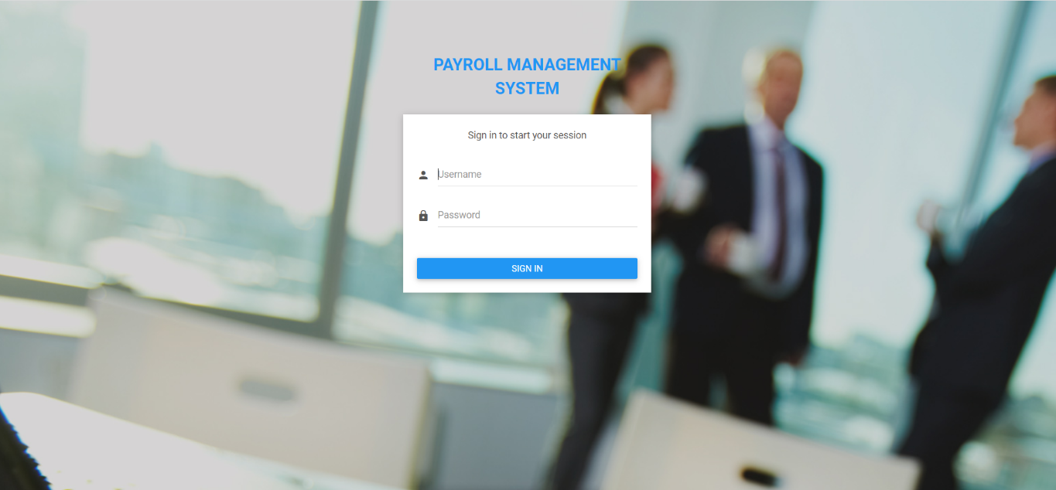

Figure: 6.1 Login System

**6.2 Admin Dashboard**

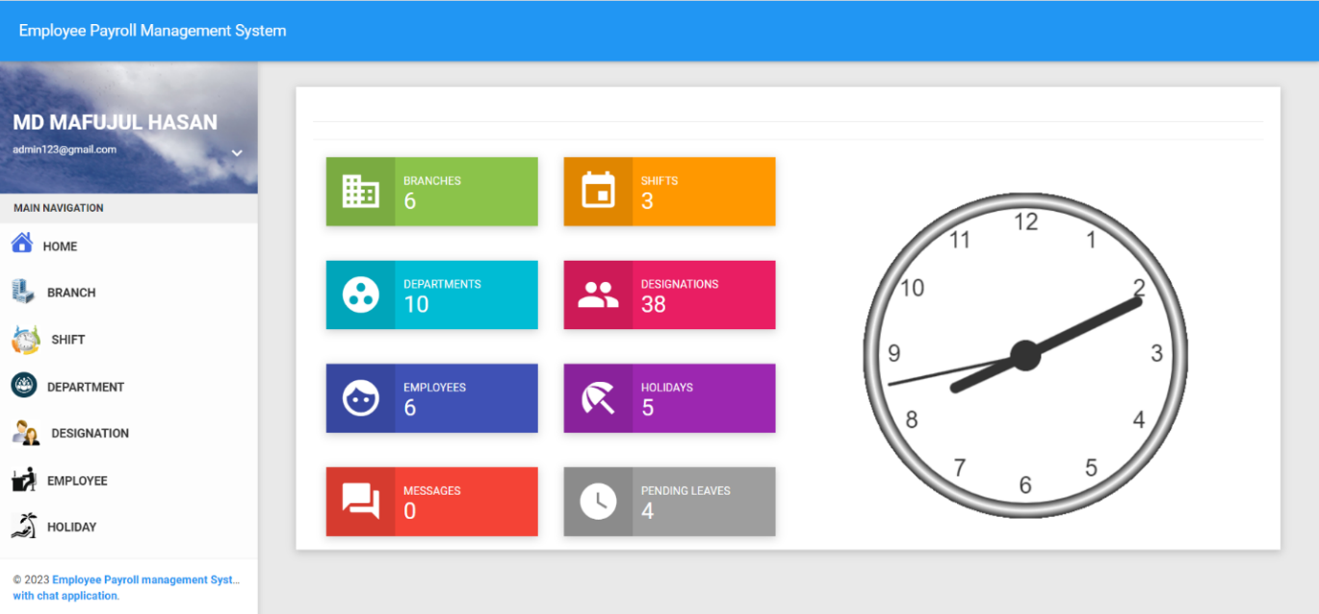

Figure: 6.2 Admin Dashboard

**6.3 Employee Dashboard**

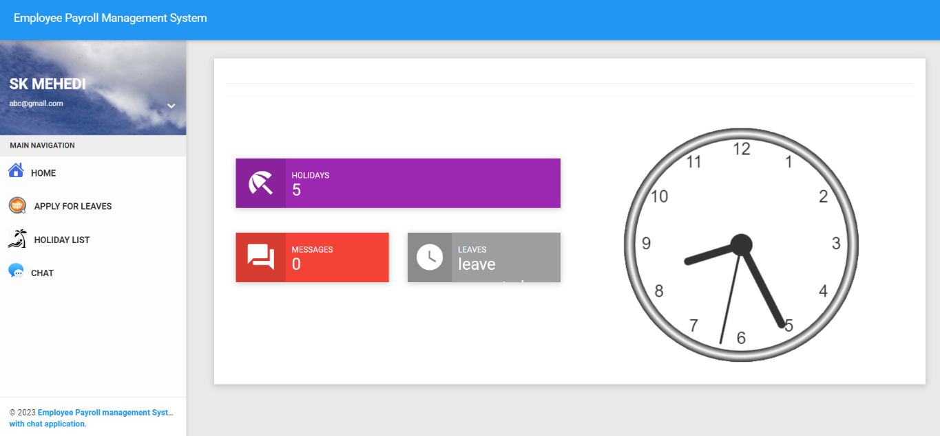

Figure: 6.3 Employee Dashboard

**6.4 Branch View**

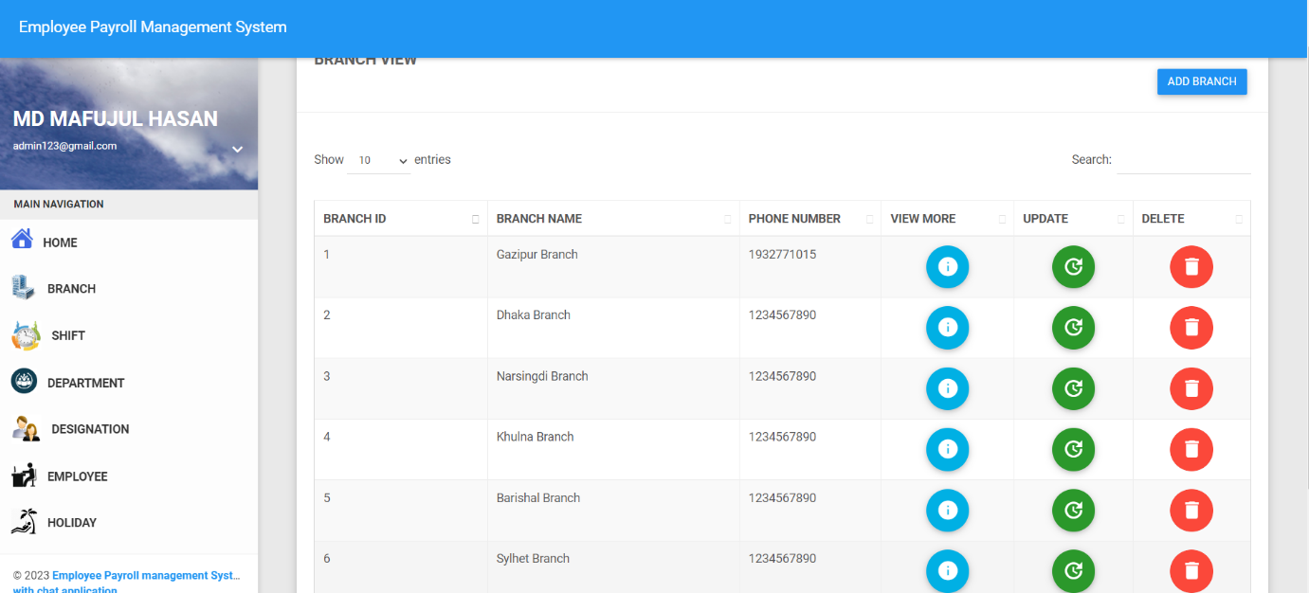

Figure: 6.4 Branch View

**6.5 Shift View**

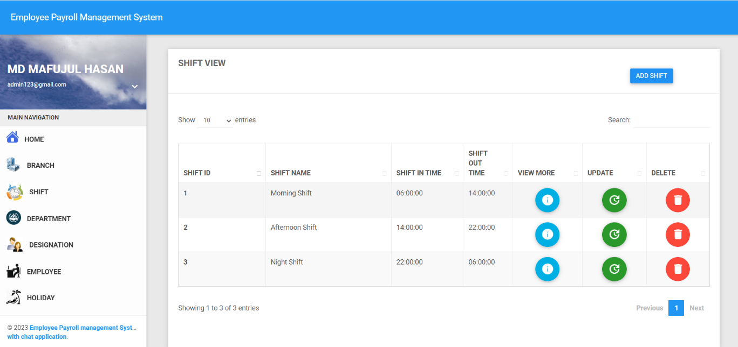

Figure: 6.5 Shift View

**6.6 Department View**

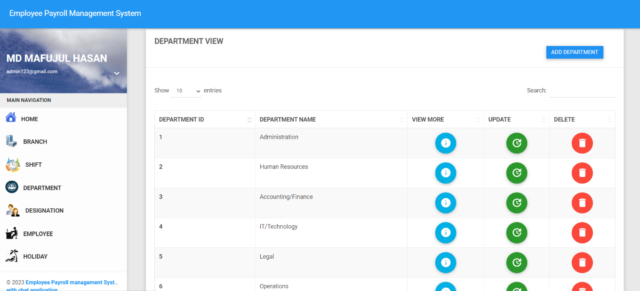

Figure: 6.6 Department View

**6.7 Designation View**

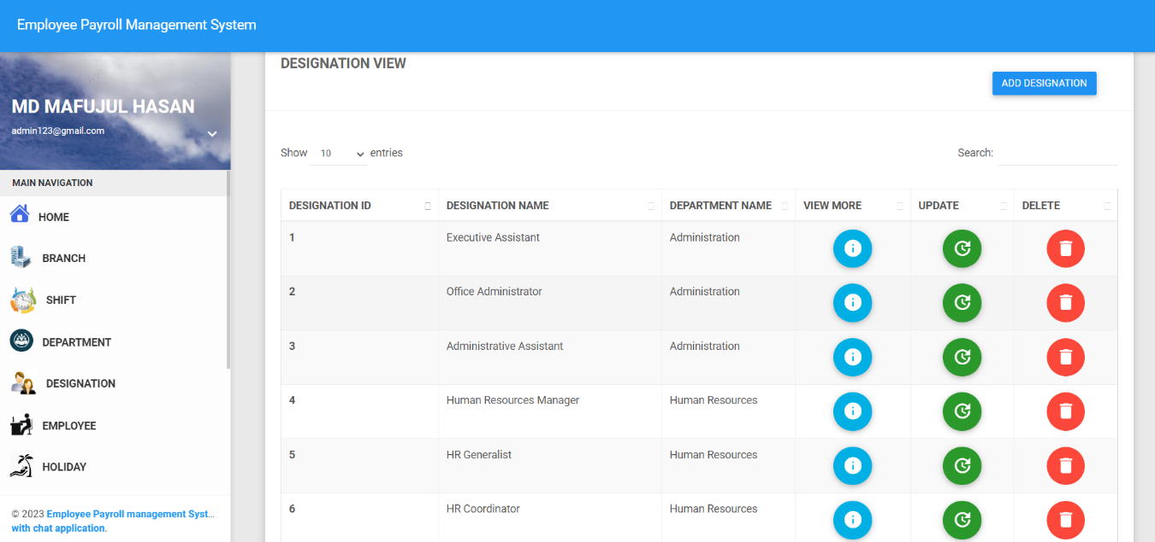

Figure: 6.7 Designation View

**6.8 Employee List View**

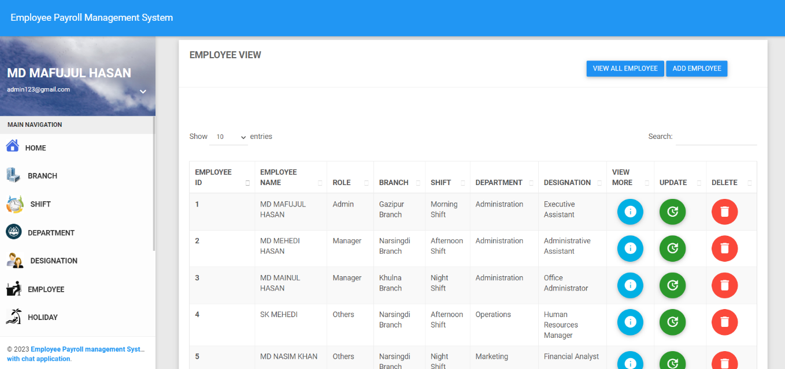

Figure: 6.8 Employee List View

**6.9 Holiday List View**

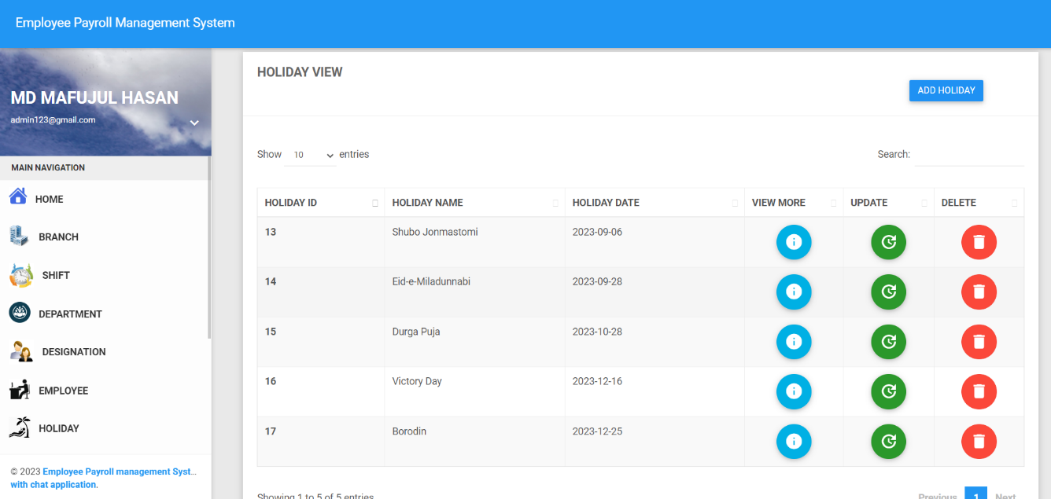

Figure: 6.9 Holiday List View

**6.10 Leave List View**

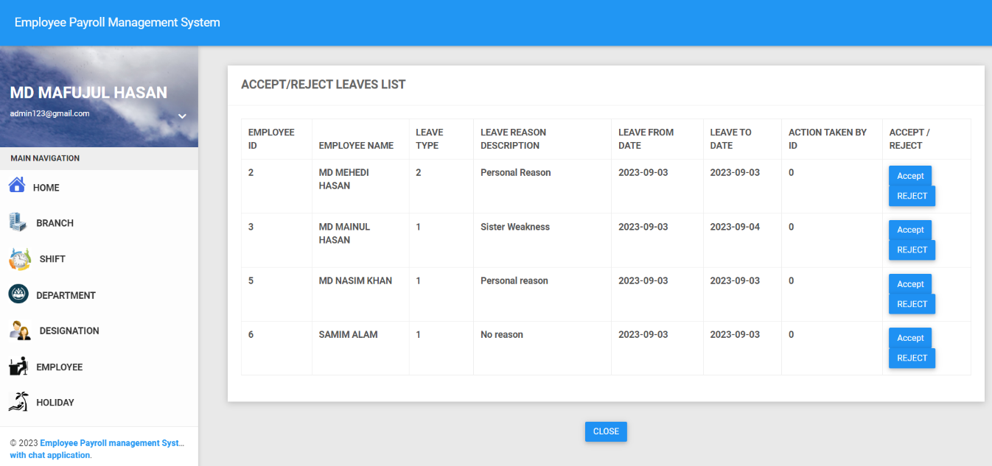

Figure: 6.10 Leave List View

**6.11 Performance Analysis of an Employee**

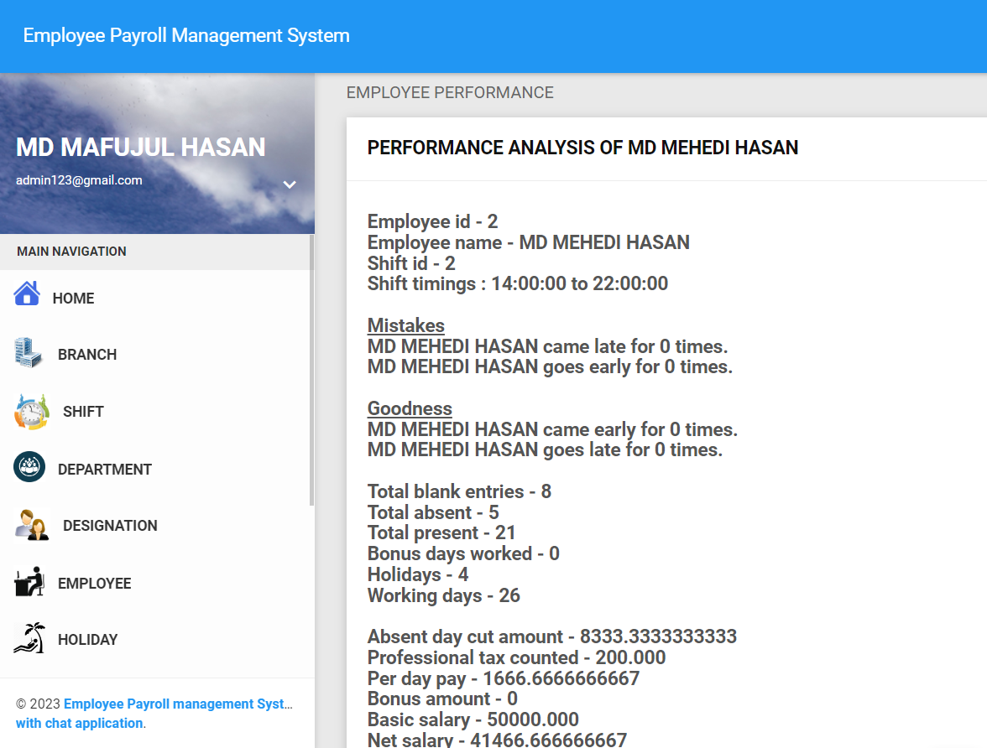

Figure: 6.11 Performance analysis of an Employee

**6.12 Payslip Generate**

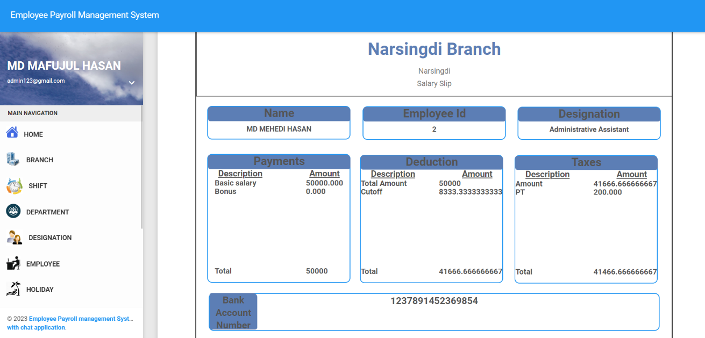

Figure: 6.12 Payslip Generate

**6.13 Biometric Report View**

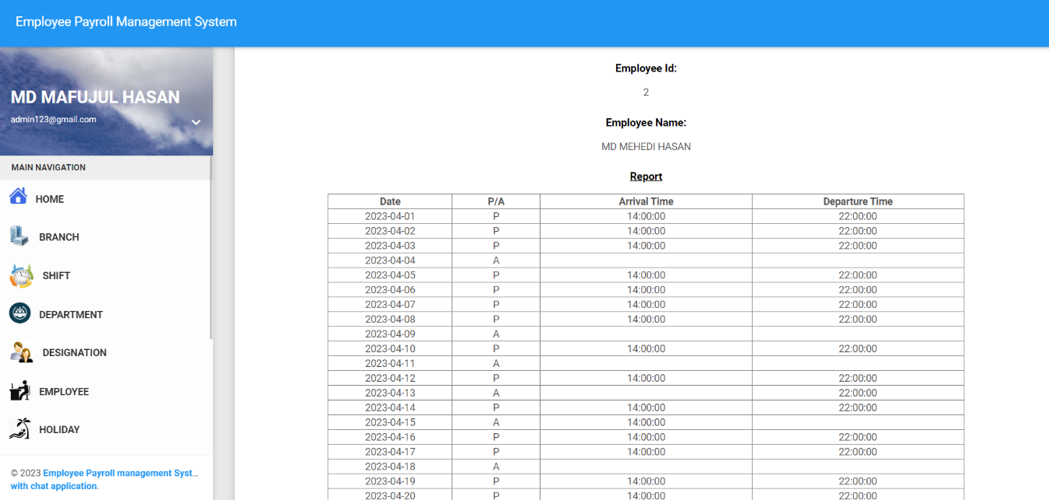

Figure: 6.13 Biometric Report View

**6.14 Employee Chat Window View**

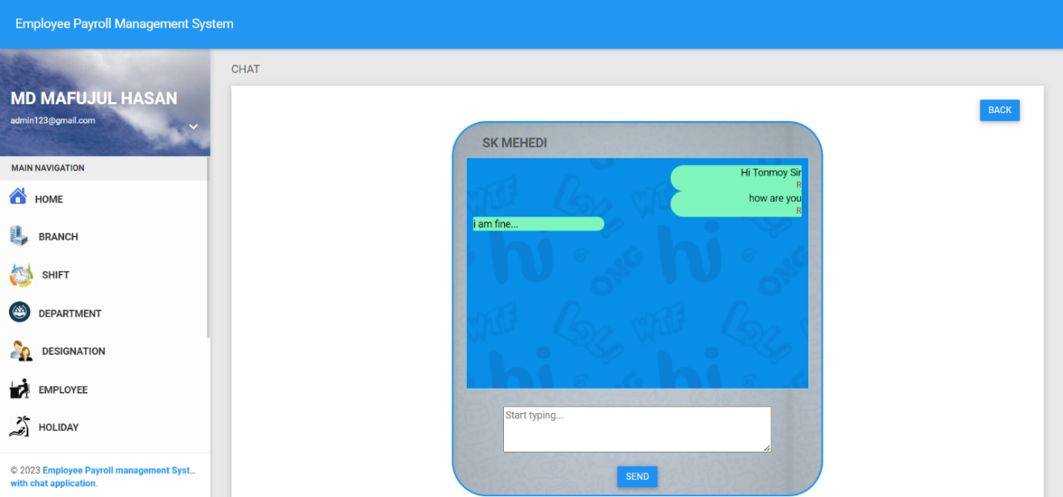

Figure: 6.14 Employee Chat Window View

**CHAPTER 7**

**CONCLUSION AND FUTURE WORKS**

**7.1 Conclusion**

With the economic and social developments, people's living standards have been increased with higher standards. After improving living, people desire to improve their daily life and have more demand for technology services. In the past, most of information services are individual or hand-writing based. There lacks of either internal system integration or cross boundary sharing and collaborations. But now, people are very conscious about time, and also to increase the awareness of people become dependent on the management of modern technology services because new technology of the people brings a good opportunity.

**7.2 Limitations**

We have to face many different problems while implementing this project. At the same time, we try to make an adjustment while those problems occurred such as:

1. Online payment is not currently available in this system.
2. This application does not yet provide any functionality to process the stored data for future use.
3. It does not also include complete payroll management system.

**7.3 Future Work**

We can consider much future work scope to this project. The following areas that can be implemented are:

1. In future live information system for database will be developed.
2. It can be used any kind of multinational organization.
3. It can be modified OOP Server script Language.
4. In future instead of SQL Server, it will be used Oracle database.

**REFERENCES**

1. Brown, A., Smith, J., & Johnson, L. (2020). "Design and Implementation of Employee Information and Payroll Management Systems." International Journal of Human Resource Management, 25(3), 178-194.
2. Johnson, K., Smith, A., & Brown, L. (2022). "Design and Implementation of Employee Information and Payroll Management System: A Literature Review." Journal of Human Resource Management, 40(3), 87-105.
3. Rodriguez, M., Lee, S., & Thompson, J. (2022). "Payroll Management Systems: Design and Implementation Considerations - A Literature Review." International Journal of Human Resource Technology, 12(4), 145-163.
4. Johnson, M., & Smith, J. (2020). "Identifying gaps in the design and implementation phases of employee information and payroll management systems." International Journal of Human Resources Management, 24(3), 178-195.
5. Smith, John. "Design and Implementation of Employee Information and Payroll Management System." Journal of Human Resource Technology, vol. 12, no. 3, 2021, pp. 45-62.
6. "Unified Modeling Language," OMG Unified Modeling Language (OMG UML), accessed September 5, 2023, <https://www.uml.org/>.
7. Weygandt, J. J., Kimmel, P. D., & Kieso, D. E. (2019). Managerial accounting: Tools for business decision-making. John Wiley & Sons.
8. Pressman, R. S. (2014). Software engineering: a practitioner's approach. Palgrave Macmillan.
9. Myburgh, C. P., & Pineda, L. R. (Eds.). (2018). Routledge companion to strategic human resource management. Taylor & Francis.